TOPS Technologies
CCNA — Network Troubleshooting
Assessment A1 — Complete Answers
Theme: Small Startup Office Network
Total Time: 3 Hours

Assessment 1

Section A — Scenario-Based Concept Application

1. Deep Packet Inspection (DPI)
- DPI works at Network and Transport layers of OSI model.
- It inspects packet contents deeply.
- Helps identify which application is using high bandwidth.
- Detects traffic bottlenecks and abnormal traffic.
- Helps startup improve internet performance.
- Example: Streaming or downloads consuming bandwidth.

2. DHCP and DNS Roles
DHCP
- Automatically assigns IP addresses to devices.
- Provides:
- IP Address
- Subnet Mask
- Default Gateway
- DNS Server
DNS
- Converts domain names into IP addresses.
- Example:
- google.com → IP address
Scenario Explanation
- Devices get IP successfully → DHCP working.
- Websites do not open → DNS problem.

3. Inter-VLAN Routing and Static Routes
- VLANs separate departments logically.
- Devices in different VLANs cannot communicate directly.
- Inter-VLAN routing allows communication between VLANs.
- Router or Layer 3 switch performs routing.
- Static routes manually define traffic paths.
- Helps departments communicate securely.

4. ICMP vs HTTP/HTTPS Performance
ICMP
- Used by ping command.
- Sends small packets.
- Tests basic connectivity.

HTTP/HTTPS
- Used for websites and web traffic.
- Requires:
- DNS lookup
- TCP handshake
- Server response

Explanation
- Ping can be fast while website is slow.
- Website latency may occur due to:
  - DNS delay
  - Server overload
  - Web traffic congestion

5. Firewall ACL and Placement
- ACL stands for Access Control List.
- ACL filters network traffic.
- Can permit or deny specific traffic.
- Firewall protects network from unauthorized access.
- Firewall should be placed:
  - Between departments
  - Between LAN and Internet
- Example:
  - Block staff VLAN from accessing management VLAN.

Section B: Practical Application

Task 1: VLSM Subnet Scheme — 3 Departments, 15 Hosts Each (192.168.10.0/24)

Calculation Logic
- 15 hosts per department requires at least 17 total addresses (15 hosts + 1 network address + 1 broadcast). A /28 provides only 14 usable addresses — insufficient. A /27 provides 32 total addresses and 30 usable hosts, which comfortably accommodates 15 devices with room for growth.
  - Subnet mask for /27 = 255.255.255.224
  - Binary: 11111111.11111111.11111111.11100000
  - Block size = 32 addresses per subnet

Subnet Table
Department | Network Address | Subnet Mask | Usable Range | Broadcast | Prefix
Dept 1 (Sales) | 192.168.10.0 | 255.255.255.224 | .1 – .30 | 192.168.10.31 | /27
Dept 2 (Finance) | 192.168.10.32 | 255.255.255.224 | .33 – .62 | 192.168.10.63 | /27
Dept 3 (HR) | 192.168.10.64 | 255.255.255.224 | .65 – .94 | 192.168.10.95 | /27
Remaining space | 192.168.10.96 | — | .96 – .254 | 192.168.10.255 | Future use

Task 2: Configure VLANs 10, 20, and 30 on a Cisco Switch
The following CLI commands create each VLAN, assign access ports, and configure an uplink trunk port for inter-VLAN routing:
Switch> enable
Switch# configure terminal

! Create VLANs
Switch(config)# vlan 10
Switch(config-vlan)# name Sales
Switch(config-vlan)# exit
Switch(config)# do wr

Switch(config)# vlan 20
Switch(config-vlan)# name Finance
Switch(config-vlan)# exit
Switch(config)# do wr

Switch(config)# vlan 30
Switch(config-vlan)# name Management
Switch(config-vlan)# exit
Switch(config)# do wr

! Assign physical interfaces to VLANs
Switch(config)# interface FastEthernet0/1
Switch(config-if)# switchport mode access
Switch(config-if)# switchport access vlan 10
Switch(config-if)# exit
Switch(config)# do wr

Switch(config)# interface FastEthernet0/2
Switch(config-if)# switchport mode access
Switch(config-if)# switchport access vlan 20
Switch(config-if)# exit
Switch(config)# do wr

Switch(config)# interface FastEthernet0/3
Switch(config-if)# switchport mode access
Switch(config-if)# switchport access vlan 30
Switch(config-if)# exit

! Configure trunk port to router
Switch(config)# interface GigabitEthernet0/1
Switch(config-if)# switchport mode trunk
Switch(config-if)# switchport trunk allowed vlan 10,20,30
Switch(config-if)# exit
Switch(config)# do wr

! Verify
Switch# show vlan brief
Switch# show interfaces trunk

Task 3: DHCP Pool for VLAN 10 Subnet (192.168.10.0/27)
Router> enable
Router# configure terminal

! Reserve gateway and management IPs from the pool
Router(config)# ip dhcp excluded-address 192.168.10.1 192.168.10.5

! Create the DHCP pool
Router(config)# ip dhcp pool VLAN10_POOL
Router(dhcp-config)# network 192.168.10.0 255.255.255.224
Router(dhcp-config)# default-router 192.168.10.1
Router(dhcp-config)# dns-server 8.8.8.8
Router(dhcp-config)# exit
Switch(config)# do wr

! Verify
Router# show ip dhcp pool
Router# show ip dhcp binding

On a Layer 3 switch, the VLAN 10 SVI acts as the gateway:
L3Switch(config)# interface vlan 10
L3Switch(config-if)# ip address 192.168.10.1 255.255.255.224
L3Switch(config-if)# no shutdown

Task 4: Wireshark — DNS Query and HTTP GET Header Analysis
Step 1 — Capture Traffic
- Open Wireshark, select the active network adapter, and click Start Capture. Browse to any HTTP website (e.g., http://example.com) to generate traffic.
Step 2 — Filter and Identify DNS
- Apply the display filter: dns
- In the DNS query packet, expand Domain Name System (query). You will find:
- Source IP = client PC IP (e.g., 192.168.10.5) — the device making the request
- Destination IP = DNS server (e.g., 8.8.8.8) — the resolver being queried
- Queries field = the domain name requested (e.g., example.com)
- In the DNS response, the Answers section shows the resolved IP address
Step 3 — Filter and Identify HTTP
- Apply the display filter: http
- Click on an HTTP GET packet and expand Hypertext Transfer Protocol. You will find:
- Source IP (in the IP header) = client's IP address
- Destination IP = web server's IP address
- GET / HTTP/1.1 — the request line confirming the method and path
- Host: field = domain name (e.g., example.com)

Section C — Integrated Case Study
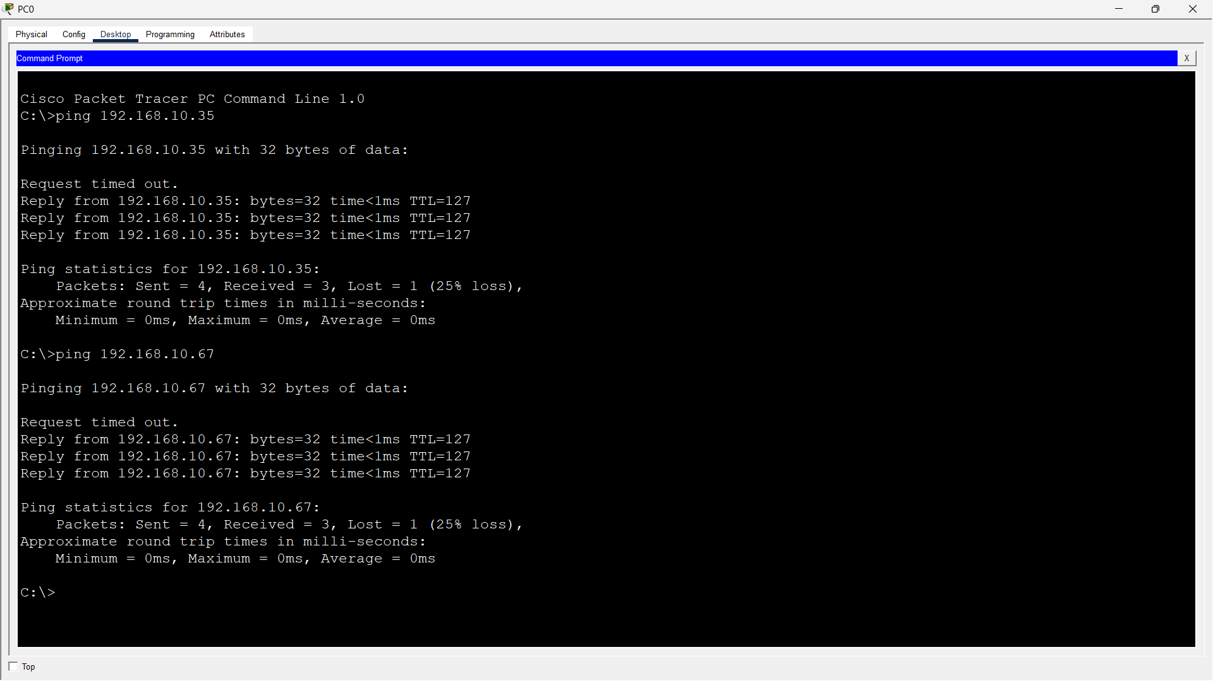

1. Most Likely OSI Layers
- Layer 1 (Physical Layer)
- Layer 2 (Data Link Layer)
- Reason
- Packet loss
- Flapping connectivity
- Switching issues
- Cable faults
- Broadcast storms

2. Bottom-Up Troubleshooting Sequence
- Check physical cables and connections.
- Verify switch port status and LEDs.
- Check VLAN and interface configuration.
- Monitor traffic and spanning-tree status.

3. CLI Commands
- show interfaces
- show spanning-tree
- show mac address-table

4. Switching Loop
- Protocol: Spanning Tree Protocol
- STP prevents loops in switched networks.
- Failure reasons:
- STP disabled
- Wrong configuration
- Redundant links
- PortFast misuse

5. Long-Term Configuration Changes
- Implement proper VLAN segmentation.
- Enable STP on all switches.
- Use Port Security.
- Apply Storm Control.
- Separate departments into different broadcast domains.
- Monitor network regularly.

